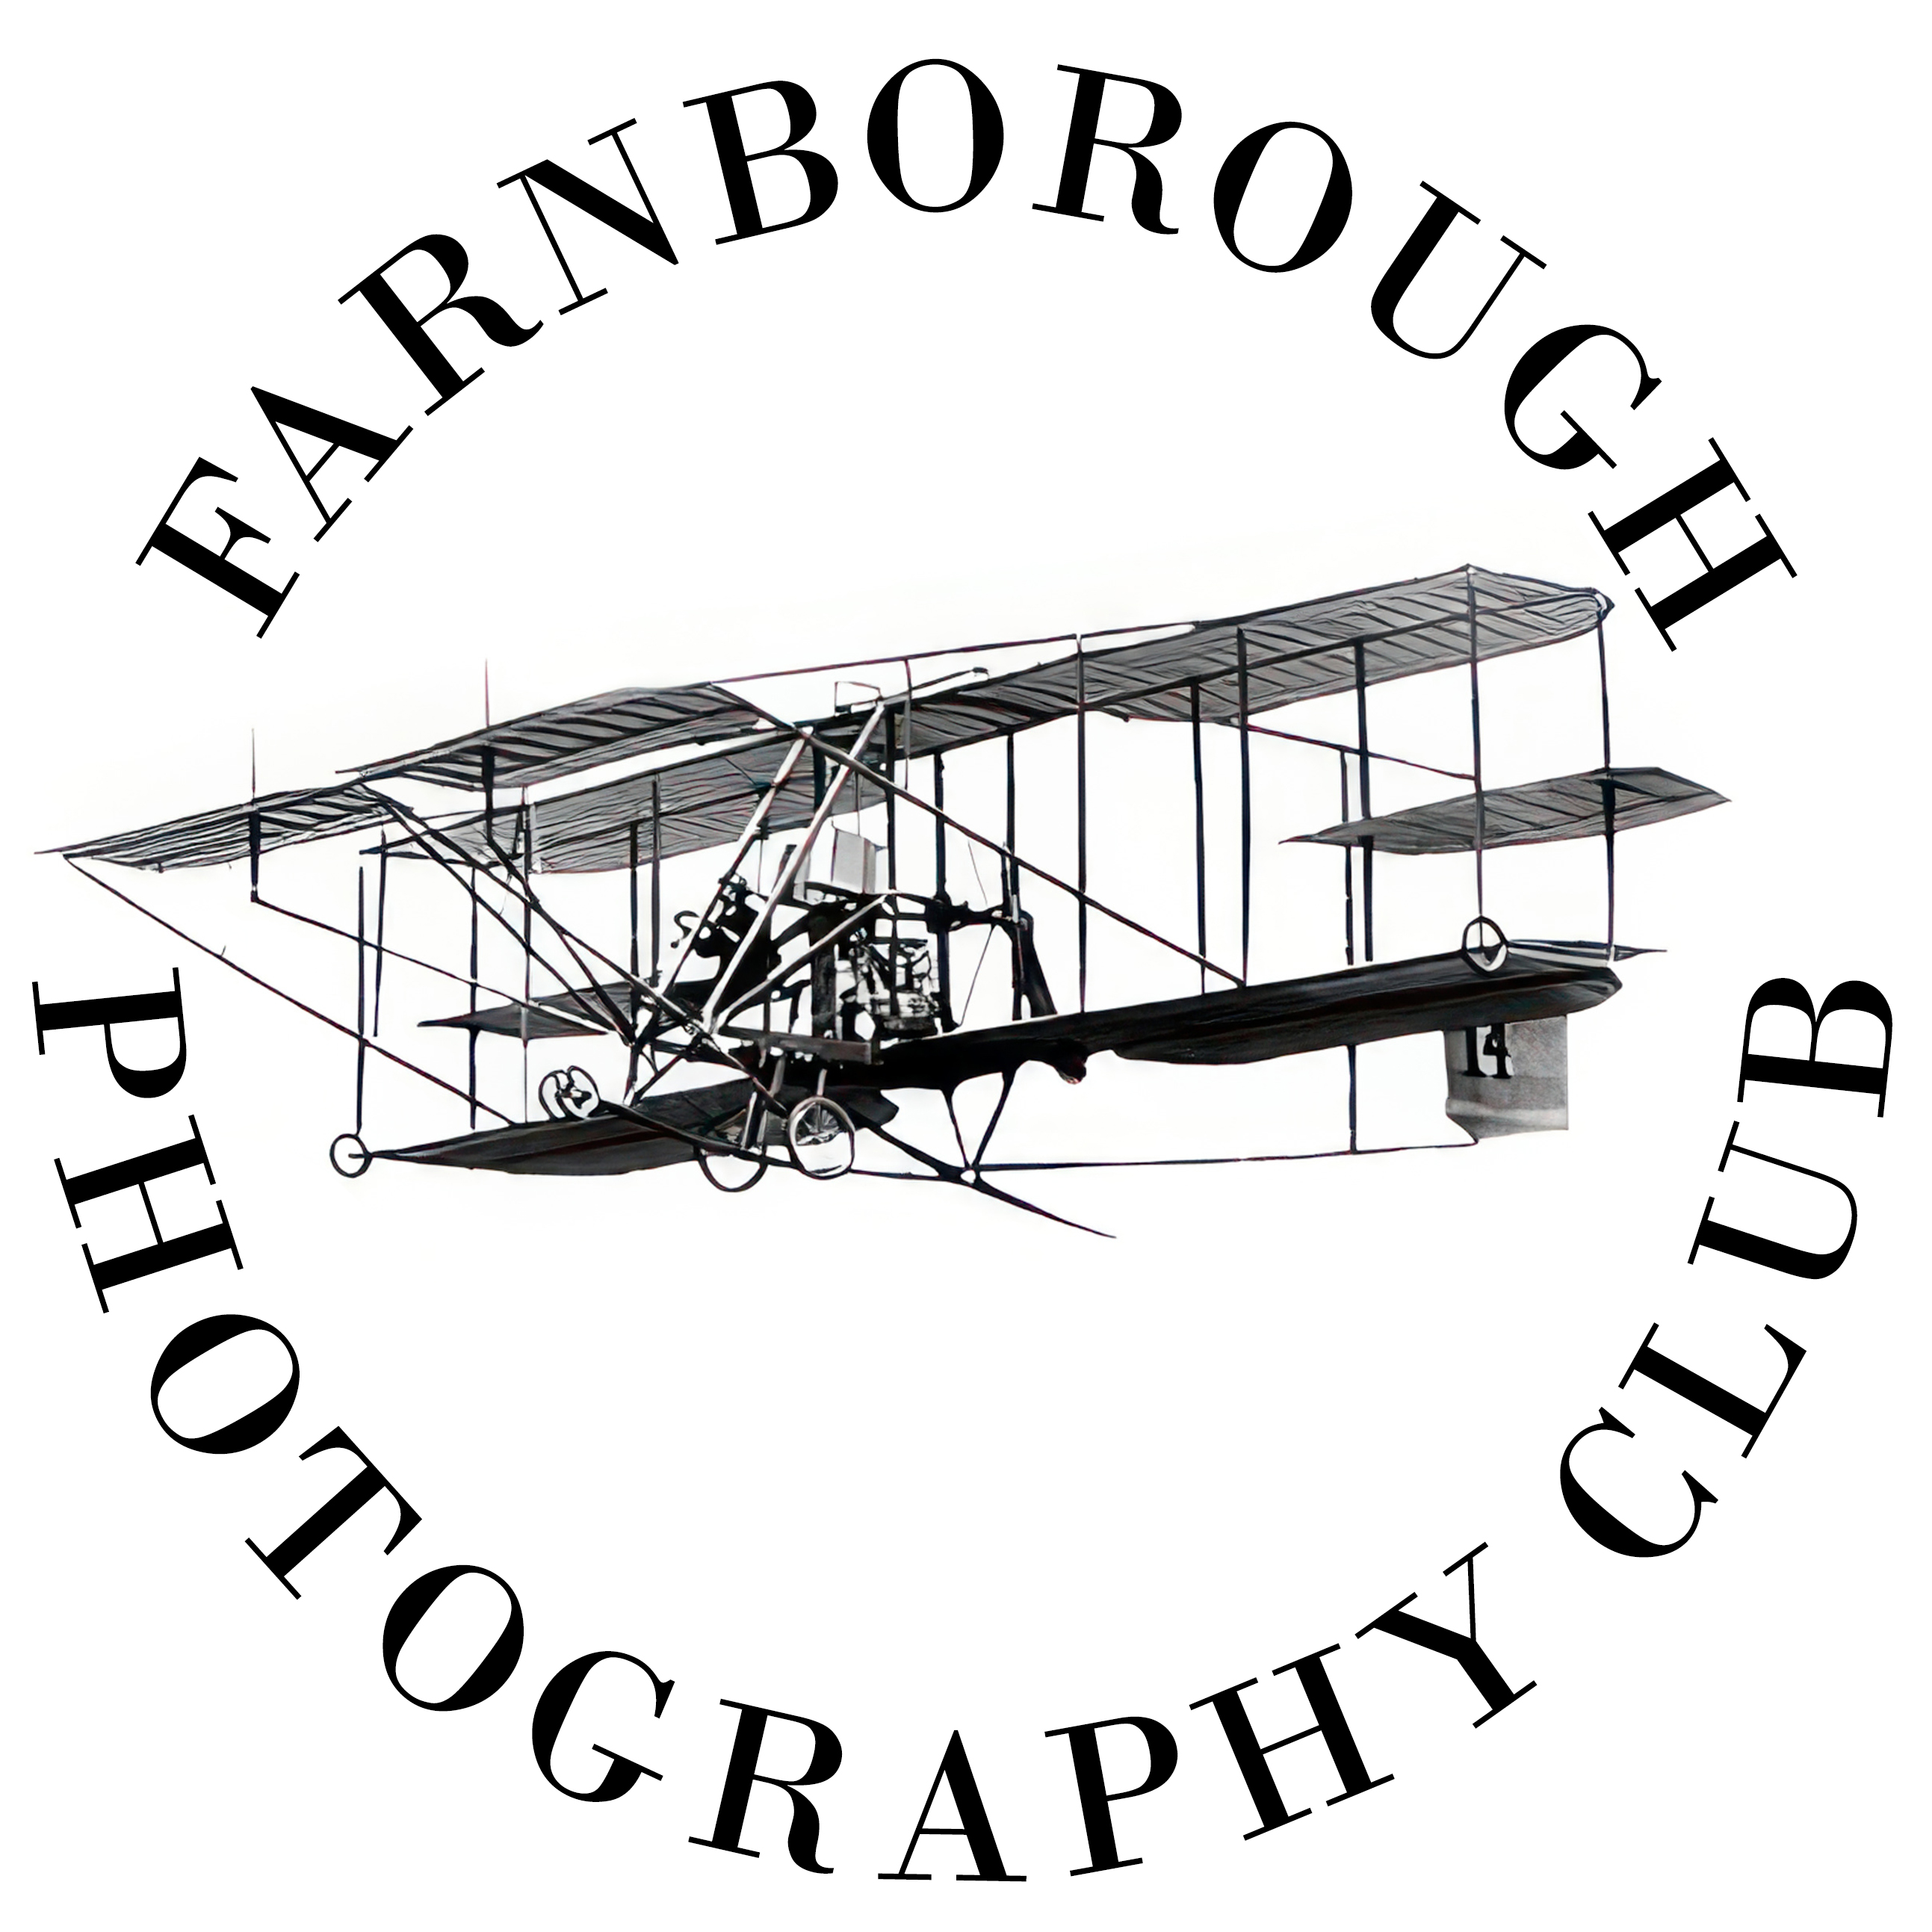
FARNBOROUGH PHOTOGRAPHY CLUB -

MEMBERSHIP FORM

Personal Details:

Title
Surname
First

Address Post Code
DoB

Email Address

Telephone: Home Mobile

Information About Your Photography:

Photographic Honours (eg RPS/PAGB/BIPP etc)
Photographic Interests and Skills

Which types of photography are you interested in?
Landscape Yes No
Travel Yes No
Portrait Yes No
Action Yes No
Natural History/Wildlife Yes No
Creative Yes No
Macro Yes No
Street Photography Yes No
Other (name)

Do you have any photographic skills?
Studio work Yes No
Digital processing (eg Photoshop) Yes No
Other (describe)
Your Camera(s)
Make and Model

Main Lenses

Year Membership Commenced

I apply for membership of Farnborough Camera Club and hereby agree that:

- my personal data can be held by the Club in accordance with the Club Data Protection Policy and can be shared with other Club members for the purposes of communicating with each other.
- the Club may send me emails from time to time about the Club, its meetings and competitions, and about external events of photographic interest (some of these may be communications forwarded from third parties).
- any images entered by me into Club competitions can be used by the Club for any purpose (except anything of a commercial nature) unless I specifically advise the Club Chairman in writing. Where my images are entered into external competitions, some of my personal data may be supplied to the external body running the competition (eg SCPF, PAGB, etc).
- I will read the Club’s Handbook (available on the Club website) and will abide by its rules and policies.

Signed: ________________________________ Date: ___________

